Lakewood Forest Fund Homeowner Association

Board Meeting of Trustees Meeting Minutes
April 6, 2026

A regular meeting of the Board of Directors of the Lakewood Forest Fund, Inc. was held in person and via Zoom.

Directors Present: Ben Anderson, Mary Davis, Michael Hahn, Philip Swift, Craig Estepp, Heidi Flores were present at the meeting.

Also in Attendance: Tami Smith, General Manager, Katherine Rios, Administrative Assistant, ten homeowners present in person, and eight homeowners present on the zoom call.

EXECUTIVE SESSION
With notice properly served and quorum duly established, the meeting was called to order at 6:01 PM. The Board reviewed inspection report, AR delinquency, and Legal Status reports.
Adjournment: with no other business, the meeting adjourned to the Open Session at 6:59 PM.

OPEN SESSION
With notice properly served and quorum duly established, the meeting was called to order at 7:03 PM.

Ben Anderson introduced Katherine Rios as the new administrative assistant.

Captain Rodrigez presented the constable statistic report.

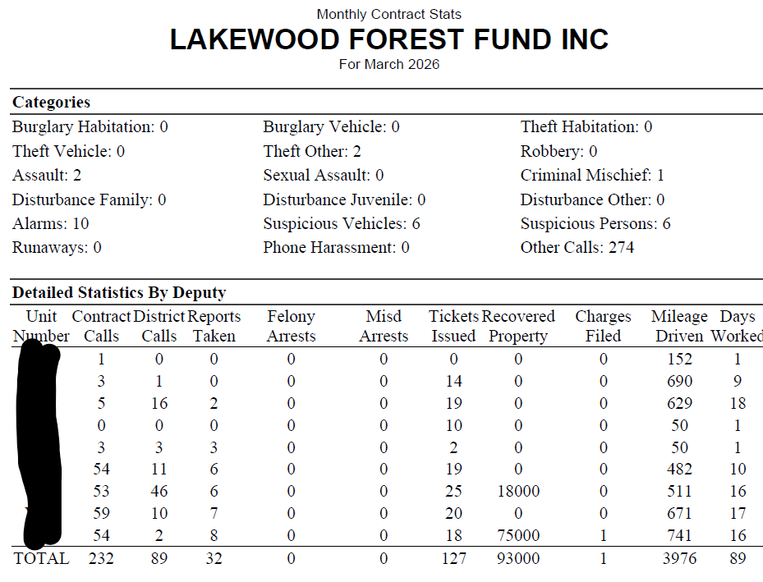

EXECUTIVE SESSION BUSINESS
Upon a motion duly made and seconded, the motion to submit six (6) deed violation homeowners to the attorney for corrective action was approved.

Upon a motion duly made and seconded, the motion to move forward with force mow ten-day letters and action was approved.

Upon a motion duly made and seconded, the motion to move forward with request from the attorney to move forward with authorization to file suit on eight (8) homeowner accounts was approved. Daughtry & Farine account numbers: 2531-0041, 2531-0042, 2531-0046, 2531-0050, 2531-0051, 2531-0052, 2531-0052, 2531-0053, and 2531-0054.

Upon a motion duly made and seconded, the motion of changes to the ADP account contract, not to exceed $100 month, was approved.

RATIFICATIONS OF ACTIONS TAKEN OUTSIDE OF A MEETING
Board approved purchase of Laptop computer and accessories for the administrative assistant position at a cost not to exceed $1,000 was approved. The actual cost was a total of $893.36

APPROVAL OF MEETING MINUTES
Upon a motion duly made and seconded, the meeting minutes from March 2026 were approved as presented.

FINANCIAL REPORT
Philip Swift presented the financial report for March 2026. Details included but were not limited to, 2026 Assessment collection is at 77% and 2025 collection is at 90%.

Lone Star Bookkeeping has completed the integration of the accounting books for 2024. The 2024 accounting documents will be forwarded to Cox CPA firm who will perform the audit. Lone Star should have 2025 books in order by the end of June.

OLD BUSINESS
Tami Smith reported the homeowners past due letters went out in the mail.

NEW BUSINESS
Upon a motion duly made and seconded, the contract with Impress Computers for office IT support was approved at a cost of $475 a month was approved.

The By-Laws Amendment to change quorum was presented, discussed and was tabled until additional information can be obtained from the attorney.

Next meeting is scheduled for May 4, 2026

With no further business, the meeting adjourned at 7:50 PM

