Lakewood Forest Fund Homeowner Association

Board Meeting of Trustees Meeting Minutes
July 6, 2026

A regular meeting of the Board of Directors of the Lakewood Forest Fund, Inc. was held in person and via Zoom.

Directors Present: Ben Anderson, Mary Davis, Michael Hahn, Philip Swift, and John Harden were present at the meeting. Craig Estepp was not present.

Also in Attendance: Tami Smith, General Manager, eleven homeowners present in person, and six homeowners present on the zoom call.

EXECUTIVE SESSION
With notice properly served and quorum duly established, the meeting was called to order at 6:05 PM. The Board reviewed inspection report, AR delinquency, and Legal Status reports.
Assistant Chief Toby Hecker discussed with the board the upcoming Constable contract and creating a usage agreement for the office space utilized by Pct 4.
Adjournment: with no other business, the meeting adjourned to the Open Session at 6:58 PM.

OPEN SESSION
With notice properly served and quorum duly established, the meeting was called to order at 7:03 PM.

Lt. C Weikel presented the constable statistic report.
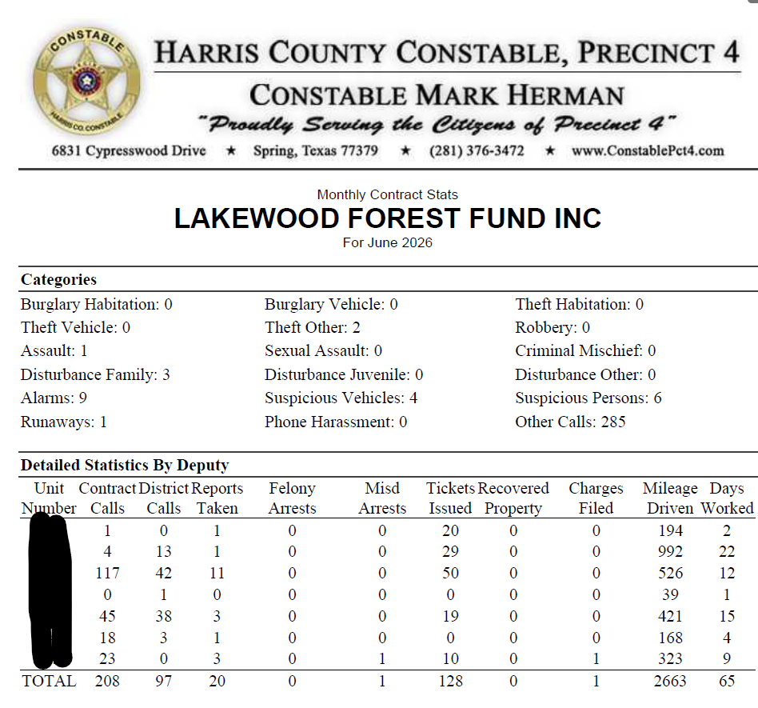

EXECUTIVE SESSION BUSINESS:
No business required voting.

RATIFICATIONS OF ACTIONS TAKEN OUTSIDE OF A MEETING
Approval to post on Indeed for an Administrative Assistant.

Approval for emergency replacement of HVAC system for second floor of office building at a cost of $10,960.88

Approval for replacement of both HVAC systems for first floor and replacement of ducting at a cost of $27,256.00

Approval for replacement of the water heater at a cost of $2,900.00

Approval for replacement of plant material missing at monuments and wing walls at a cost of $1,725.00.

Approval for changing to Caliber/Front-Steps HOA software effective September 1, 2026.

APPROVAL OF MEETING MINUTES
Upon a motion duly made and seconded, the meeting minutes from June 2026 were approved as presented.

FINANCIAL REPORT
Philip Swift presented the financial report for June 2026. Details included but were not limited to, 2026 Assessment collection is at 87.2% and 2025 collection is at 92.6%.

Lone Star Bookkeeping has completed the accounting books for Q3 2025 and is working on completing 2025 by the end of the month.

OLD BUSINESS
The insurance claim filed due to the previous manager theft has been resolved. The Fund is to receive a check for total amount of loss, less the deductible.

Proposal from LED partners for new laptop and updated software was tabled.

The By-Laws Amendment to change quorum was tabled until Fall.

NEW BUSINESS
New Administrative Assistant will begin on July 13, 2026.

Next meeting is scheduled for August 3, 2026

With no further business, the meeting adjourned at 7:23 PM

