Lakewood Forest Fund Homeowner Association

Board Meeting of Trustees Meeting Minutes
August 3, 2026

A regular meeting of the Board of Directors of the Lakewood Forest Fund, Inc. was held in person and via Zoom.

Directors Present: Ben Anderson, Mary Davis, Michael Hahn, Craig Estepp and John Harden were present at the meeting. Philip Swift was absent.

Also in Attendance: Tami Smith, General Manager, Amy Hoffman, Admin, ten homeowners present in person, and six homeowners present on the zoom call.

EXECUTIVE SESSION
With notice properly served and quorum duly established, the meeting was called to order at 5:58 PM. The Board reviewed inspection report, AR delinquency, Legal Status reports, updating the paint color listing, additional tree planting proposal and adding an aerator to the lake.
Adjournment: with no other business, the meeting adjourned to the Open Session at 6:57 PM.

OPEN SESSION
With notice properly served and quorum duly established, the meeting was called to order at 7:00 PM.

Lt. Westmorland presented the constable statistic report.
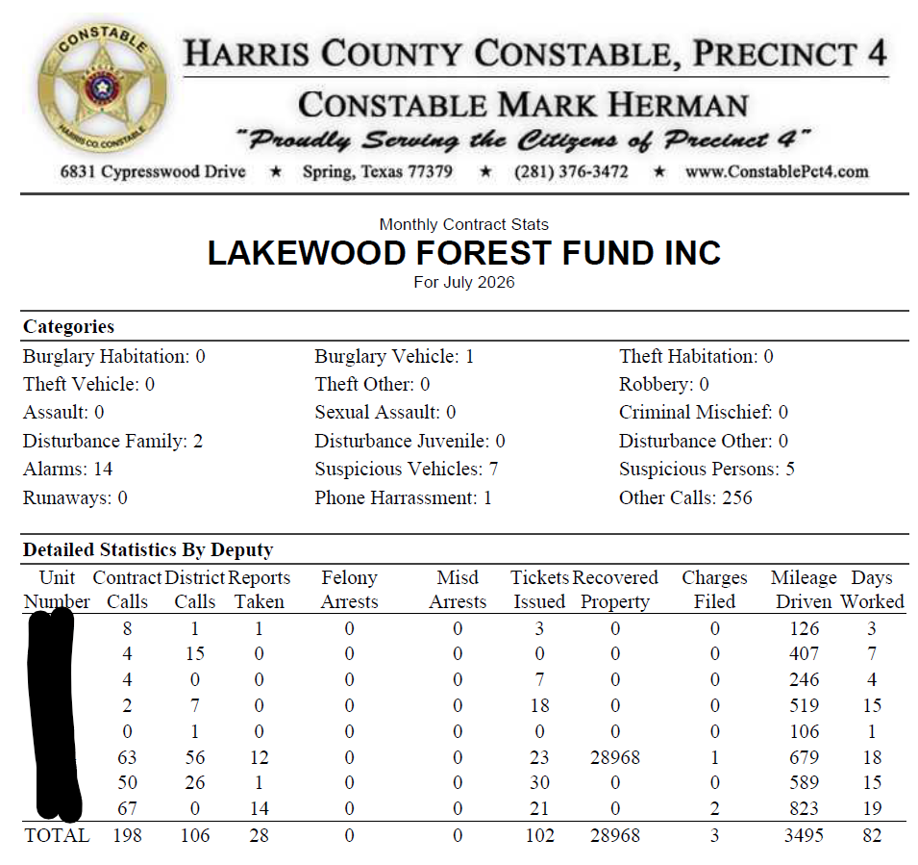

EXECUTIVE SESSION BUSINESS:
Upon a motion duly made and seconded, all past due accounts under $2,000 that have been sent a 209 letter are approved to go to attorney for collections.

Upon a motion duly made and seconded, repairs to the gate and latch at Dick Taylor Lake were approved.

Upon a motion duly made and seconded, Precinct 5 Constable contract for oct 2026 – Sept 2027 was approved.

Solitude Lake aerator Proposal for adding aeration to the Dick Taylor Lake was rejected.

ACC paint color list needs updating; the board appointed Michael Hahn to lead this project.

RATIFICATIONS OF ACTIONS TAKEN OUTSIDE OF A MEETING
Approval of Attorney request to waive fees due to statute of limitations.

APPROVAL OF MEETING MINUTES
Upon a motion duly made and seconded, the meeting minutes from July 2026 were approved as presented.

FINANCIAL REPORT
Ben Anderson presented the financial report for July 2026. Details included but were not limited to, 2026 Assessment collection is at 89.2%.

Lone Star Bookkeeping has completed the accounting books for 2025 and is working on completing Q1 2026 by the end of the month.

OLD BUSINESS
John updated the board on the proposal from LED partners for new laptop and updated software, which was tabled. No response from LED partners to John’s email.

NEW BUSINESS

Next meeting is scheduled for September 14, 2026

With no further business, the meeting adjourned at 7:46 PM

