Lakewood Forest Fund Homeowner Association

Board Meeting of Trustees Meeting Minutes
September 14, 2026

A regular meeting of the Board of Directors of the Lakewood Forest Fund, Inc. was held in person and via Zoom.

Directors Present: Ben Anderson, Mary Davis, Michael Hahn, Craig Estepp, Philip Swift and John Harden were present at the meeting.

Also in Attendance: Tami Smith, General Manager, nine homeowners present in person, and seven homeowners present on the zoom call.

EXECUTIVE SESSION
With notice properly served and quorum duly established, the meeting was called to order at 6 PM. The Board reviewed inspection report, AR delinquency, Legal Status reports, updating the paint color listing, additional tree planting proposal and adding an aerator to the lake.
Adjournment: with no other business, the meeting adjourned to the Open Session at 6:58 PM.

OPEN SESSION
With notice properly served and quorum duly established, the meeting was called to order at 7:06 PM.

Lt. Weickel presented the constable statistic report.
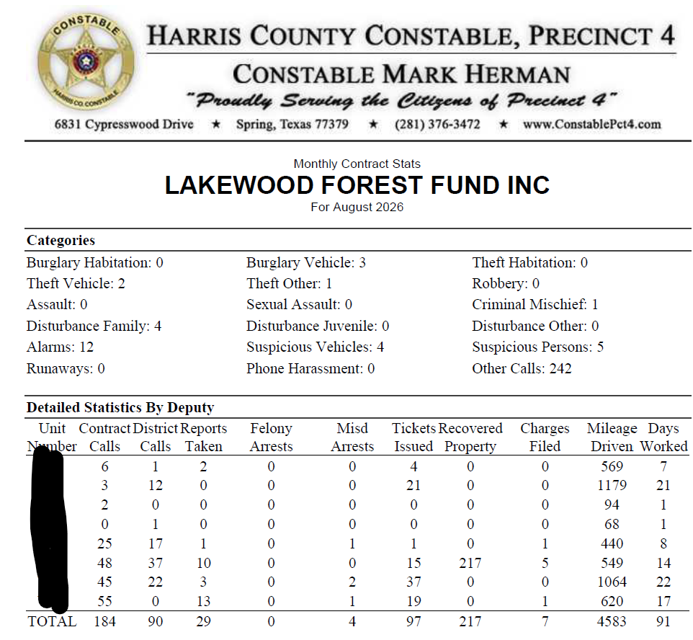

EXECUTIVE SESSION BUSINESS:
Upon a motion duly made and seconded, the homeowner ACC appeal for a variance was denied.

RATIFICATIONS OF ACTIONS TAKEN OUTSIDE OF A MEETING
There were none for this month.

APPROVAL OF MEETING MINUTES
Upon a motion duly made and seconded, the meeting minutes from August 2026 were approved with corrections.

FINANCIAL REPORT
Philip Swift presented the financial report for August 2026. Details included but were not limited to 2026 Assessment collection is at 90.3%.

OLD BUSINESS
John updated the board on the proposal from LED partners for new laptop and updated software, which was tabled. Tami will inquire if the replacement proposal is still a valid price and report at next meeting.

There was no NEW BUSINESS.

Next meeting is scheduled for October 5, 2026

With no further business, the meeting adjourned at 7:35 PM

